1.Use the information provided in the table below to calculate the volume reduction and weight reduction in percent due to recycling.

|  |  |  |  |  |  |  |  |
| --- | --- | --- | --- | --- | --- | --- | --- |
| **Component** | **Disposed waste composition (% by wt.)** | **Recycling efficiency (%)** | **Density (lb/ff3)** | **volume**  **ft3** | **weight reduction**  **(lb)** | **volume reduction**  **(%)** | **weight reduction**  **(%)** |
| Mixed paper | 37 | 10 | 5.6 | 6.6 | 3.7 | 3.7 | 3.7 |
| Metals | 3 | 80 | 20.0 | 0.2 | 2.4 | 0.7 | 2.4 |
| Plastics | 43 | 30 | 4.1 | 10.5 | 12.9 | 17.6 | 12.9 |
| Organics | 17 | 15 | 18.1 | 0.9 | 2.6 | 7.9 | 25.5 |
| sum: | 100 | N/A | N/A | 18.2 | 21.6 | 22.4 | 21.6 |

SOLUTION

Assume that the total weight of the solid waste is 100lb.

Volume of the Mixed paper:37/5.6=6.61

Mixed paper ‘s weight is 37%*100kg=37lb

The weight reduction of Mixed paper: 37*10%=3.7lb

weight reduction of Mixed paper:3.7lb/100lb=3.7%

1. Determine the size of the landffll required to serve a community with a population of 100,000 for ten years. The community has a waste generation rate of 4.67 lb/capita/day and a by weight recycling rate of 33.8%. Assume that the disposal rate, and recycling rate will remain constant and waste density of 1,500 lb/yd3, while the population grows at a rate of 5% per year.

**SOLUTION**

1. Waste Generation Data：

Generate Rate is constant, hower, the population grows at a rate of 5% per year. Thus the Waste Generation Volume grows at a rate of 5% per year.

The community has a waste disposal rate of 4.67 lb/capita/day

1. Waste Disposal Data：

Rcycling rate is 33.8%.;

Disposal rate is 66.2%;

Waste Disposal Rate : Waste disposal rate = ( 4.67 lb generated person ⋅ day ) × ( 66.2 lb disposed 100 lb generated ) = 3.09 lb generated

Yearly waste disposal = ( 3.09 lb disposed person ⋅ day )× (population) ×(365 days)

Total volume of waste disposed = Yearly waste disposal× ( 1/1500 yd3/ lb ) (27 ft 3 /yd3 )

Wast Volume Calculation Table

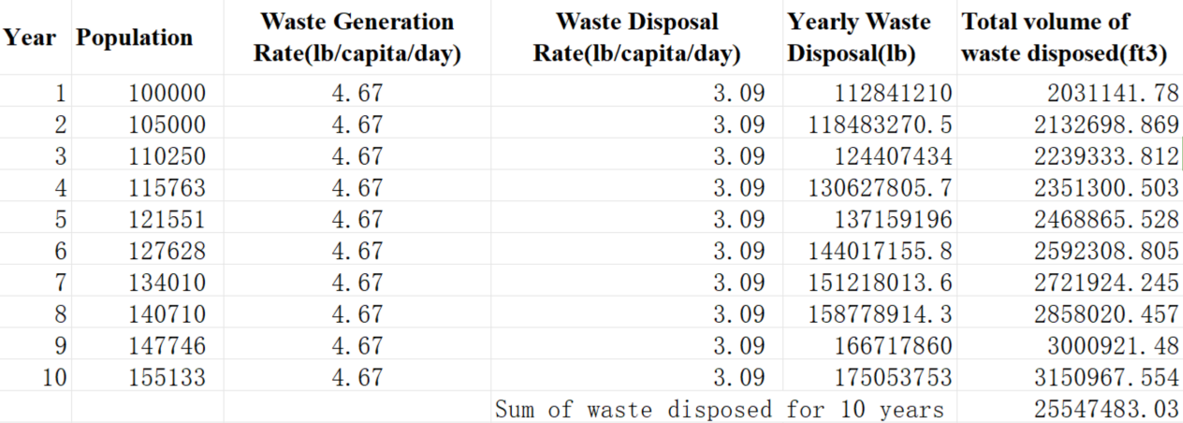

1. Assume that the waste occupies 90% of the landffll volume:

Landfill volume = 2.55 × 107 ft 3 (100 ft 3 /landfill 90 ft 3 waste )=2.83 × 107ft 3

1. Assume a landffll height of 100 ff and side slopes with N=3 (3 run : 1 rise), Landffll height (H) = 100 ft, then solve Equation (8.12) for L, length and width of base, using the Quadratic

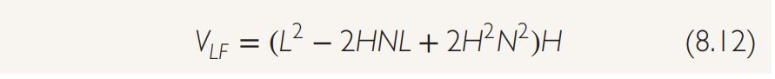Equation or a root solver program. Solution using Microsoff Excel’s Solver tool yields L = 669 ff.

Final Landffll Design:

• Side slopes (run:rise) = 3 : 1

•Landffll height (H) = 100 ft

• Length and width of landffll base (L) = 740 ft /or 750 ft

• Area required for base = 547,600 ft2 /or 562,500 ft2= 12.57 acres /or 12.91 acres

• Landffll volume (airspace) = 2.83 × 107 ft3 /or2.92 × 107 ft3

1. Assume the chemical composition of a MSW sample can be represented as C550H700O700N10S. Estimate the energy content based using the Dulong formula.(Example Problem 8.4)

Solution:

Step 1

Compose a calculations table to determine the percent weight contribution made by each element in the representative compound.

|  |  |  |  |  |
| --- | --- | --- | --- | --- |
| **Component** | **Number of atoms**  **per mole** | **Atomic weight** | **Elemental weight contribution**  **per mole** | **% Weight**  **Contribution** |
| C | 550 | 12 | 6600 | 35.4 |
| H | 700 | 1 | 700 | 3.8 |
| O | 700 | 16 | 11200 | 60.0 |
| N | 10 | 14 | 140 | 0.8 |
| S | 1 | 32 | 32 | 0.2 |
| TOTAL |  |  | 18672 | 100 |

Step 2

Apply the Dulong Formula (Equation 8.9)

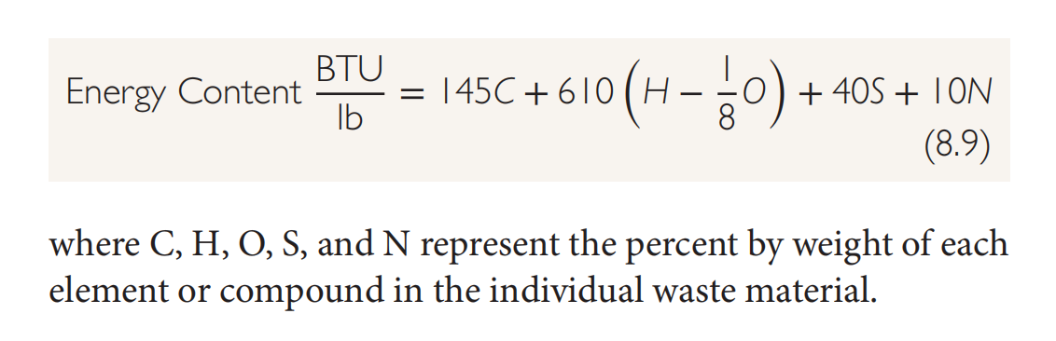

Energy Content = [145(35.35) + 610 ( 3.75 − (59.98) /8) + 40(0.17) + 10(0.75)] BTU/lb =5125.75-2285.975+6.8+7.5=2854.075BTU/lb